**ATAR course examination, 2023**

**MODERN HISTORY**

**SOURCE BOOKLET**

|  |  |  |
| --- | --- | --- |
| **Source set** | **Elective** | **Related question** |
| 1 | Capitalism and the American Experience, 1907 - 1941 | 1 |
| 2 | Nazism in Germany | 23 |

**Set 1: Elective:**

**Capitalism and the American Experience, 1907 – 1941**

**Source 1**

*Excerpt from the textbook “The United States: A History of the Republic”, 1987*

Andrew Mellon . . . . favored a high tariff that would protect American business from foreign competition. Consistent with Mellon’s views, Congress passed the Fordney-McCumber Act in 1922, raising tariffs to a new high.

Mellon also believed that taxes on large incomes should be reduced. If taxes were lowered, he argued, the wealthy would have more money to invest. More investment would create more jobs, which would mean more income for middle- and lower-income people. Mellon believed wealth would ‘trickle down’ and improve the standard of living for everyone. A majority of Congress agreed with Mellon’s reasoning. The Revenue Act of 1921 and other new tax laws slashed taxes on higher incomes.

**Source 2**

*Cartoon created January 1, 1925 and published in the US*

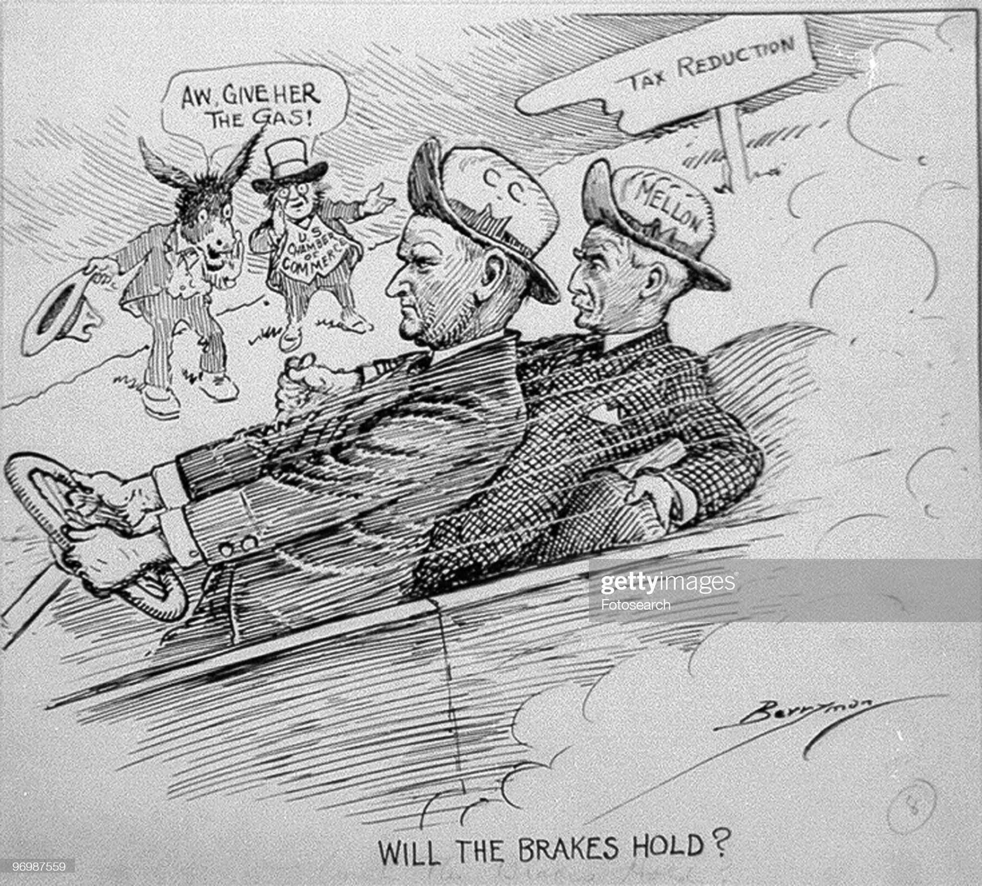

*Image portrays Coolidge and Mellon riding in a car with the Democratic Donkey and US Chamber of Commerce egging them on; Mellon has his hands on the parking brake.*

**Source 3**

*Excerpt from the textbook “The USA: A Divided Union”, 1994*

Wealthy business organisations, such as the American Liberty League, opposed Roosevelt. They did not like the way the New Deal ‘interfered’ with businesses and gave support to workers. The League was formed by a group of conservative businessmen that included Al Smith and John Davis, two previous Democratic presidential candidates – but its main support came from rich enemies of Roosevelt who despised him because, although a rich man himself, he had chosen to help the poor.

**Source 4**

*Excerpt from an interview with economist Gardiner Means, economic adviser to the Roosevelt administration from the book “Hard Times: An Oral History of the Great Depression”, 1970*

What Roosevelt and the New Deal did was turn about and face the realities. . . . A hundred years from now, when historians look back on it, they will say a big corner was turned. People agree that old things didn’t work. What ran through the whole New Deal was finding a way to make things work.

Before that Hoover would loan money to farmers to keep their mules alive, but wouldn’t loan money to keep their children alive. This was perfectly right in the framework of classical thinking. If an individual couldn’t get enough to eat, it was because he wasn’t on the ball. The New Deal said: anybody who is unemployed isn’t necessarily unemployed because he’s shiftless*.

**\*shiftless –** characterised by laziness or a lack of ambition

**END OF DOCUMENT SET**

**Set 2: Elective: Nazism in Germany**

**Source 1**

*The Horst Wessel Song, used as an anthem of the Nazi Party and co-national anthem of Germany from 1933 – 1945. Written in 1929.*

Flag high, ranks closed

The SA marches with silent solid steps.

Comrades shot by the red front and reaction

March in spirit with us in our ranks.

The street free for the brown battalions,

The street free for the Storm Troopers.

Millions, full of hope, look up at the swastika;

The day breaks for freedom and for bread.

For the last time the call will now be blown;

For the struggle we now all stand ready.

Soon will fly Hitler-flags over every street;

Slavery will last only a short time longer.

Flag high, ranks closed,

The SA marches with silent solid steps.

Comrades shot by the red front and reaction

March in spirit with us in our ranks.

**Source 2**

*First leaflet of the White Rose, distributed in 1943 in Germany*

Isn’t it true that every honest German is ashamed of his government these days? Who among us has any conception of the dimensions of shame that will befall us and our children when one day the veil has fallen from our eyes and the most horrible of crimes – crimes that infinitely outdistance every human measure – reach the light of day?

**Source 3**

*Photo of the crowds at the 1936 Nuremberg Rally*

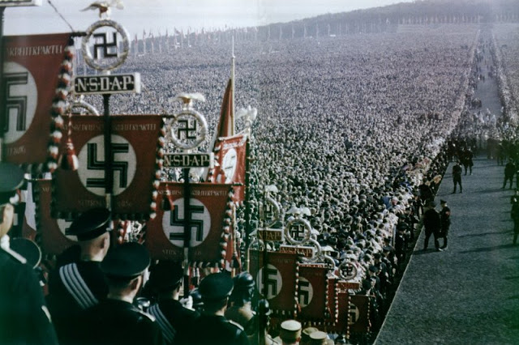

**Source 4**

*A photograph of children in the Jewish ghetto in Theresienstadt, Czechoslovakia, taken by Red Cross representatives on June 23, 1944.*

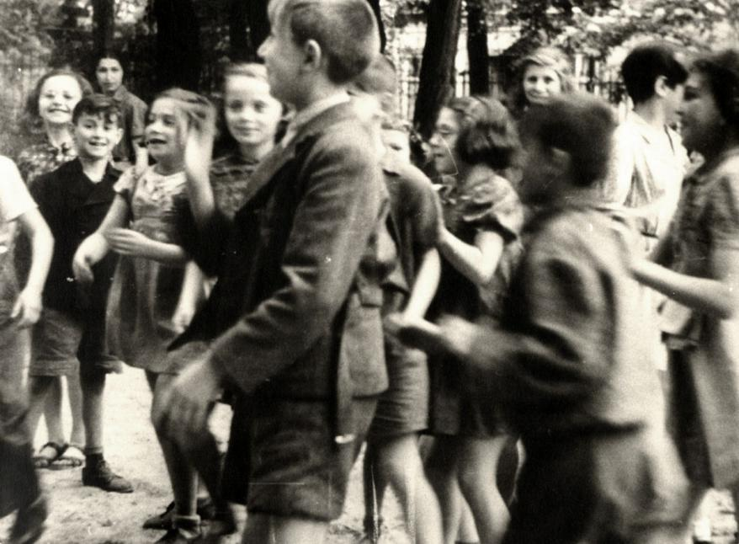

**END OF DOCUMENT SET**

**ACKNOWLEDGEMENTS**

**Set 1: Elective**

**Capitalism and the American Experience, 1907 – 1941**

**Source 1** *Excerpt from the textbook “The United States: A History of the Republic”* Davidson, James West. “The United States: A History of the Republic”, Pearson Prentice Hall: USA, 1987, p. 348.

**Source 2** *Cartoon created January 1, 1925.* Retrieved July 11, 2023, from https://www.gettyimages.com.au/detail/news-photo/political-cartoon-showing-president-calvin-coolidge-riding-news-photo/96987559

**Source 3** *Excerpt from the textbook “The USA: A Divided Union”* DeMarco, Neil. “The USA: A Divided Union”, Longman: UK, 1994, p49.

**Source 4** *Excerpt from an interview with economist Gardiner Means, economic advisor to the Roosevelt administration from the book “Hard Times: An Oral History of the Great Depression”.* Terkel, Studs. “Hard Times: An Oral History of the Great Depression”. Retrieved July 3, 2023, from https://web.archive.org/web/*20100907220536*/http://www.studsterkel.org/htimes.php

**Set 2: Elective: Nazism in Germany**

**Source 1** *The Horst Wessel Song Lyrics.* Retrieved on July 7, 2023, from https://www.anesi.com/east/horstw.htm

**Source 2** *First leaflet of the White Rose, distributed in 1943.* Retrieved on June 28, 2023, from https://www.white-rose-studies.org/pages/the-leaflets

**Source 3** *Photo of the crowds at the 1936 Nuremberg Rally.* Retrieved on July 3, 2023, from https://philoid.com/ncert/chapter/iess303

**Source 4** *Photograph of children in the Jewish ghetto in Thereinstadt, Czechoslovakia, June 23, 1944.* Retrieved June 27, 2023, from https://encyclopedia.ushmm.org/content/en/photo/jewish-children-in-the-theresienstadt-ghetto